# Executive Summary

As 1970 dawned the world’s cars averaged 149 horsepower and 17 miles per gallon… but two conflicts curtailed the world’s oil supply and auto manufacturers scrambled to offer more fuel-efficient automobiles.

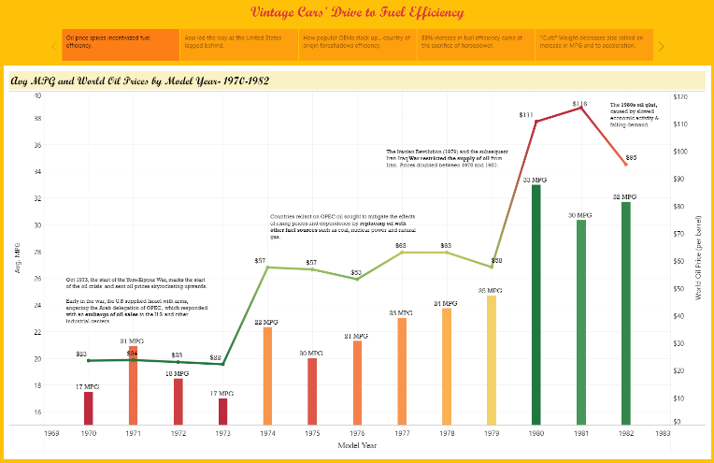Hop in and take a journey throughout the 1970s with us as we first visualize oil prices and fuel efficiency throughout the decade using Tableau.

Then we will pop the hood and see how reductions in vehicle weight, engine displacement, and horsepower brought about an 88% improvement in fuel efficiency by 1982.

As you flip through the latest digital copy of Hemmings, debating between a 1970 Pontiac GTO “The Judge” or an iconic 1975 Rolls Royce Silver Shadow, the Machine Learning models will predict the gas mileage you’ll experience with your “new” vintage beauty.

The correlation tools evaluate which characteristics have the most, and least, effect on gas mileage. Several models are then evaluated for their explanatory power of the dataset with the Random Forest ultimately selected as the best.

